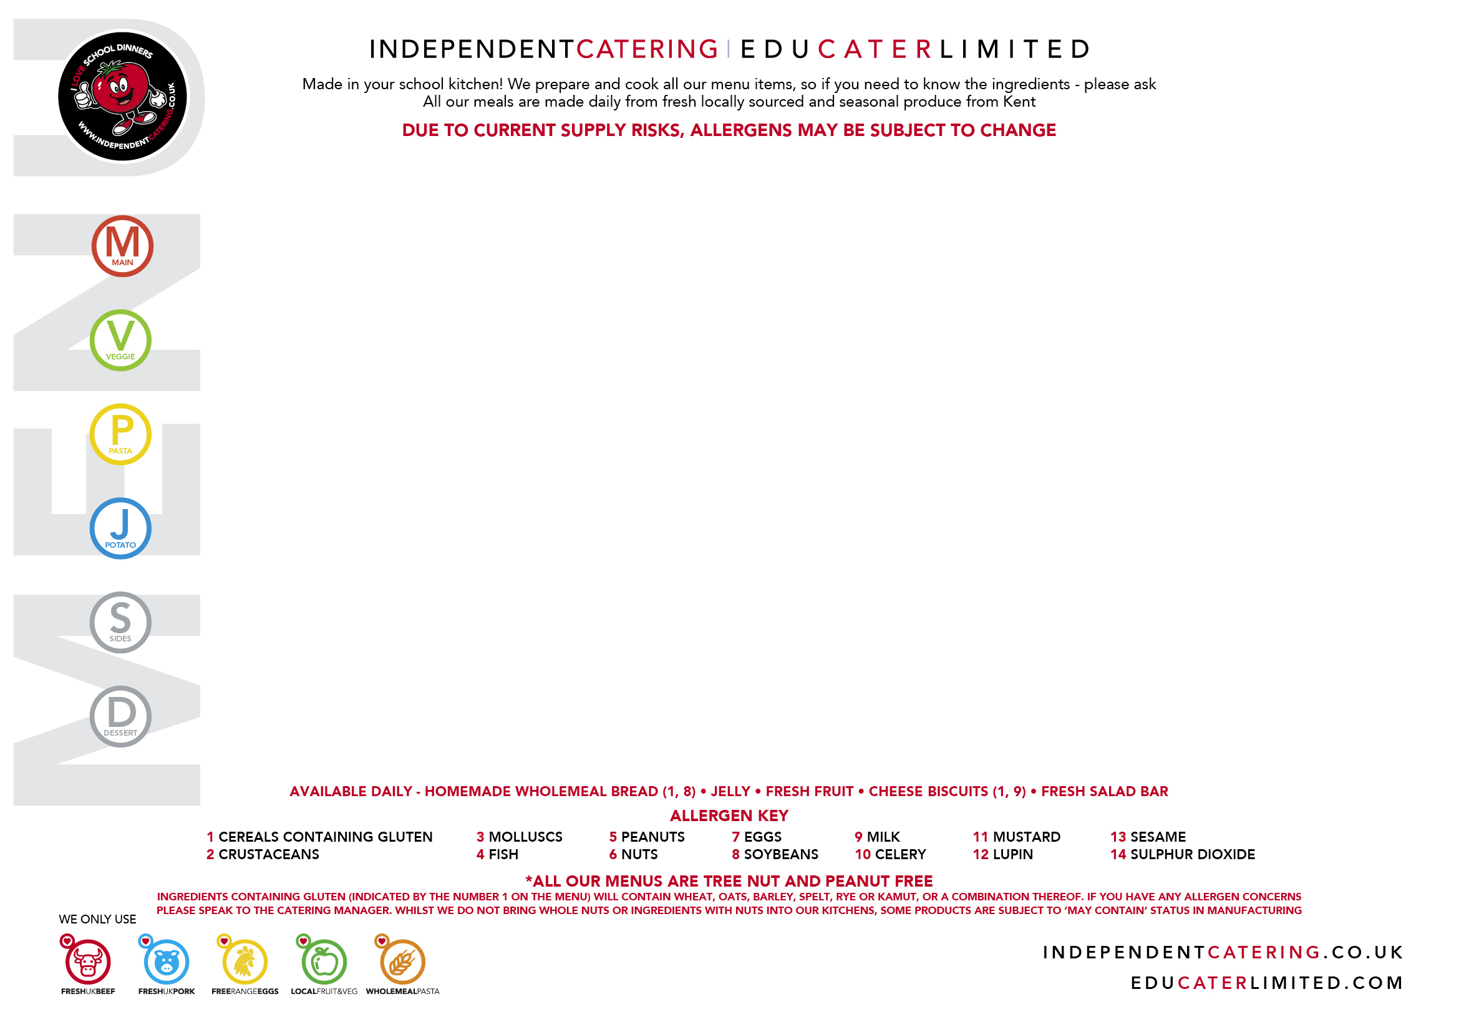

MONDAY 1 SEPTEMBER | TUESDAY 2 SEPTEMBER | WEDNESDAY 3 SEPTEMBER | THURSDAY 4 SEPTEMBER | FRIDAY 5 SEPTEMBER
Oven Baked Pork and Beef Sausages with Onion Gravy  (1, 14) | Mild Chicken Rogan Curry  with Rice  (1) | Roast Gammon  and Pineapple  with Gravy | Fajita Chicken  with Wraps  (1, 11) | Breaded Fish  (1, 4)
Oven Baked Vegetarian Crumble with Onion Gravy  (1)  VEGAN | Chickpea Korma  with Rice  (1)  VEGAN | Red Leicester and  Roast Vegetable Tart  (1, 7, 9) | Vegetable Lasagne  (1, 7, 9, 11) | Homemade BBQ Carrot  and Chickpea Burger  (1, 13)  VEGAN
Chunky Tomato Pasta  (1) | Mac n’ Cheese  (1, 9, 11) | Mixed Pepper Pasta  (1) | Fresh Pesto Pasta  (1) | Arrabiata Pasta Twirls  (1)
Jacket Potato with  Topping of the Day | Jacket Potato with  Topping of the Day | Jacket Potato with  Topping of the Day | Jacket Potato with  Topping of the Day | Jacket Potato with  Topping of the Day
Mashed Potatoes,  Garden Peas  and Salad Bar | Carrots  and Salad Bar | Roast Potatoes, Roasted Vegetables and Green Beans | Fresh Broccoli, Sweetcorn  and Salad Bar | Chips, Baked Beans  and Salad Bar
Apple and Berry Crumble  with Custard  (1, 9) | Vanilla Shortbread  (1) | Peach and Pear Sponge  with Custard  (1, 7, 9) | Tutti Frutti Thursday | Orange Drizzle Cupcakes  (1, 7)
4 CHOICE MENU
WEEK
1

MONDAY 8 SEPTEMBER | TUESDAY 9 SEPTEMBER | WEDNESDAY 10 SEPTEMBER | THURSDAY 11 SEPTEMBER | FRIDAY 12 SEPTEMBER
Beef Bolognaise  Pasta Bake and Garlic Bread  (1, 8, 9) | ‘Katsu’ Chicken Nuggets  (Sauce on the side)  (1, 8, 10) | Slow Roast Beef  with a Yorkshire Pudding  and Gravy  (1, 7, 9) | Chinese Style Chicken  with Rice  (8) | Fishfingers  (1, 4)
Butternut and Bean Bake  with New Potatoes  VEGAN | Katsu Quorn Dippers  (Sauce on the side)  (1, 8)  VEGAN | Roasted Vegetable  Puff Pastry Parcel  (1)  VEGAN | Sweet and Sour Stir Fried Vegetables and Rice  (8)  VEGAN | Cheese and Onion Turnover  (1, 9)
Mixed Vegetable  Ragu Twirls  (1) | Salmon and Pea Linguine  (1, 4, 9) | Tomato and Basil Pasta  (1) | Mac n’ Cheese  (1, 9, 11) | Mixed Vegetable  Ragu Twirls  (1)
Jacket Potato with  Topping of the Day | Jacket Potato with  Topping of the Day | Jacket Potato with  Topping of the Day | Jacket Potato with  Topping of the Day | Jacket Potato with  Topping of the Day
Sweetcorn  and Salad Bar | Savoury Rice with  Garden Peas  and Salad Bar | Roast Potatoes, Roast Carrots and Cabbage | Broccoli and  Salad Bar | Chips, Baked Beans  and Salad Bar
Berry Flapjack  (1) | Chocolate Brownie  (1, 7) | Mixed Berry Sponge  and Custard  (1, 7, 9) | Tutti Frutti Thursday | Wonky Strawberry Jelly  with Shortbread  (1)
4 CHOICE MENU

WEEK
2
MONDAY 15 SEPTEMBER | TUESDAY 16 SEPTEMBER | WEDNESDAY 17 SEPTEMBER | THURSDAY 18 SEPTEMBER | FRIDAY 19 SEPTEMBER
Homemade Sausage Rolls  (1, 14) | Very Mild Beef Chilli  with Rice and Nachos | Roast Turkey with Stuffing  and Gravy  (1) | BBQ  Chicken Pizza  (1, 9) | Fishfingers  (1, 4)
Pesto Baked Halloumi and Roasted Vegetables  with Pitta Bread  (1, 9) | Sweet Potato  and Leek Crumble  (1)  VEGAN | Roasted Tomato, Carrot  and Lentil Loaf  VEGAN | Cheese and Tomato  Pizza Wrap  (1, 9) | Quorn Dippers in a Wrap  (1, 8)  VEGAN
Roasted Spring Vegetable Pasta Bows  (1) | Mac n’ Cheese  (1, 9, 11) | Mixed Pepper Pasta  (1) | Mixed Vegetable  Ragu Twirls  (1) | Tomato Sauce served with Pasta Bows  (1)
Jacket Potato with  Topping of the Day | Jacket Potato with  Topping of the Day | Jacket Potato with  Topping of the Day | Jacket Potato with  Topping of the Day | Jacket Potato with  Topping of the Day
Potato Wedges, Sweetcorn  and Salad Bar | Garden Peas  and Salad Bar | Roast Potatoes, Carrots,  and Green Beans | Baked Beans, Diced Potatoes  and Salad Bar | Chips, Baked Beans  and Salad Bar
Apricot and  Apple Crumble  with Custard  (1, 9) | Toffee Sponge  and Custard  (1, 7, 9, 14) | Iced Carrot  Cupcakes  (1, 7, 9) | Tutti Frutti Thursday | Oaty Cherry Cookie  (1, 14)
WEEK
3
4 CHOICE MENU

MONDAY 22 SEPTEMBER | TUESDAY 23 SEPTEMBER | WEDNESDAY 24 SEPTEMBER | THURSDAY 25 SEPTEMBER | FRIDAY 26 SEPTEMBER
Oven Baked Pork and Beef Sausages with Onion Gravy  (1, 14) | Mild Chicken Rogan Curry  with Rice  (1) | Roast Gammon  and Pineapple  with Gravy |   SEE MENU BOARD  FOR DETAILS | Breaded Fish  (1, 4)
Oven Baked Vegetarian Crumble with Onion Gravy  (1)  VEGAN | Chickpea Korma  with Rice  (1)  VEGAN | Red Leicester and  Roast Vegetable Tart  (1, 7, 9) |  | Homemade BBQ Carrot  and Chickpea Burger  (1, 13)  VEGAN
Chunky Tomato Pasta  (1) | Mac n’ Cheese  (1, 9, 11) | Mixed Pepper Pasta  (1) |  | Arrabiata Pasta Twirls  (1)
Jacket Potato with  Topping of the Day | Jacket Potato with  Topping of the Day | Jacket Potato with  Topping of the Day |  | Jacket Potato with  Topping of the Day
Mashed Potatoes,  Garden Peas  and Salad Bar | Carrots  and Salad Bar | Roast Potatoes, Roasted Vegetables and Green Beans |  | Chips, Baked Beans  and Salad Bar
Apple and Berry Crumble  with Custard  (1, 9) | Vanilla Shortbread  (1) | Peach and Pear Sponge  with Custard  (1, 7, 9) |  | Orange Drizzle Cupcakes  (1, 7)
WEEK
4
4 CHOICE MENU

MONDAY 29 SEPTEMBER | TUESDAY 30 SEPTEMBER | WEDNESDAY 1 OCTOBER | THURSDAY 2 OCTOBER | FRIDAY 3 OCTOBER
Beef Bolognaise  Pasta Bake and Garlic Bread  (1, 8, 9) | ‘Katsu’ Chicken Nuggets  (Sauce on the side)  (1, 8, 10) | Slow Roast Beef  with a Yorkshire Pudding  and Gravy  (1, 7, 9) |   Spider-Man Crispy Chicken Web Wrap with Curly Fries  and Choice of Dip  Captain America’s Shield of Crispy Quorn Wrap  with Curly Fries, Peas  and Sweetcorn  Hawkeye’s Pasta Bows with Basil Tomato Sauce  Wolverine’s Jacket Potato  with Topping of the Day  Iceman’s Ice Lollies | Fishfingers  (1, 4)
Butternut and Bean Bake  with New Potatoes  VEGAN | Katsu Quorn Dippers  (Sauce on the side)  (1, 8)  VEGAN | Roasted Vegetable  Puff Pastry Parcel  (1)  VEGAN |  | Cheese and Onion Turnover  (1, 9)
Mixed Vegetable  Ragu Twirls  (1) | Salmon and Pea Linguine  (1, 4, 9) | Tomato and Basil Pasta  (1) |  | Mixed Vegetable  Ragu Twirls  (1)
Jacket Potato with  Topping of the Day | Jacket Potato with  Topping of the Day | Jacket Potato with  Topping of the Day |  | Jacket Potato with  Topping of the Day
Sweetcorn  and Salad Bar | Savoury Rice with  Garden Peas  and Salad Bar | Roast Potatoes, Roast Carrots and Cabbage |  | Chips, Baked Beans  and Salad Bar
Berry Flapjack  (1) | Chocolate Brownie  (1, 7) | Mixed Berry Sponge  and Custard  (1, 7, 9) |  | Wonky Strawberry Jelly  with Shortbread  (1)
WEEK
5

4 CHOICE MENU

MONDAY 6 OCTOBER | TUESDAY 7 OCTOBER | WEDNESDAY 6 OCTOBER | THURSDAY 9 OCTOBER | FRIDAY 10 OCTOBER
Homemade Sausage Rolls  (1, 14) | Very Mild Beef Chilli  with Rice and Nachos | Roast Turkey with Stuffing  and Gravy  (1) | BBQ  Chicken Pizza  (1, 9) | Fishfingers  (1, 4)
Pesto Baked Halloumi and Roasted Vegetables  with Pitta Bread  (1, 9) | Sweet Potato  and Leek Crumble  (1)  VEGAN | Roasted Tomato, Carrot  and Lentil Loaf  VEGAN | Cheese and Tomato  Pizza Wrap  (1, 9) | Quorn Dippers in a Wrap  (1, 8)  VEGAN
Roasted Spring Vegetable Pasta Bows  (1) | Mac n’ Cheese  (1, 9, 11) | Mixed Pepper Pasta  (1) | Mixed Vegetable  Ragu Twirls  (1) | Tomato Sauce served with Pasta Bows  (1)
Jacket Potato with  Topping of the Day | Jacket Potato with  Topping of the Day | Jacket Potato with  Topping of the Day | Jacket Potato with  Topping of the Day | Jacket Potato with  Topping of the Day
Potato Wedges, Sweetcorn  and Salad Bar | Garden Peas  and Salad Bar | Roast Potatoes, Carrots  and Green Beans | Baked Beans, Diced Potatoes  and Salad Bar | Chips, Baked Beans  and Salad Bar
Apricot and  Apple Crumble  with Custard  (1, 9) | Toffee Sponge  and Custard  (1, 7, 9, 14) | Iced Carrot  Cupcakes  (1, 7, 9) | Tutti Frutti Thursday | Oaty Cherry Cookie  (1, 14)
WEEK
6

4 CHOICE MENU

MONDAY 13 OCTOBER | TUESDAY 14 OCTOBER | WEDNESDAY 15 OCTOBER | THURSDAY 16 OCTOBER | FRIDAY 17 OCTOBER
Oven Baked Pork and Beef Sausages with Onion Gravy  (1, 14) |   SEE MENU BOARD  FOR DETAILS | Roast Gammon  and Pineapple  with Gravy | Fajita Chicken  with Wraps  (1, 11) | Breaded Fish  (1, 4)
Oven Baked Vegetarian Crumble with Onion Gravy  (1)  VEGAN |  | Red Leicester and  Roast Vegetable Tart  (1, 7, 9) | Vegetable Lasagne  (1, 7, 9, 11) | Homemade BBQ Carrot  and Chickpea Burger  (1, 13)  VEGAN
Chunky Tomato Pasta  (1) |  | Mixed Pepper Pasta  (1) | Fresh Pesto Pasta  (1) | Arrabiata Pasta Twirls  (1)
Jacket Potato with  Topping of the Day |  | Jacket Potato with  Topping of the Day | Jacket Potato with  Topping of the Day | Jacket Potato with  Topping of the Day
Mashed Potatoes,  Garden Peas  and Salad Bar |  | Roast Potatoes, Roasted Vegetables and Green Beans | Fresh Broccoli, Sweetcorn  and Salad Bar | Chips, Baked Beans  and Salad Bar
Apple and Berry Crumble  with Custard  (1, 9) |  | Peach and Pear Sponge  with Custard  (1, 7, 9) | Tutti Frutti Thursday | Orange Drizzle Cupcakes  (1, 7)
WEEK
7

4 CHOICE MENU

MONDAY 20 OCTOBER | TUESDAY 21 OCTOBER | WEDNESDAY 22 OCTOBER | THURSDAY 23 OCTOBER | FRIDAY 24 OCTOBER
Beef Bolognaise  Pasta Bake and Garlic Bread  (1, 8, 9) | ‘Katsu’ Chicken Nuggets  (Sauce on the side)  (1, 8, 10) | Slow Roast Beef  with a Yorkshire Pudding  and Gravy  (1, 7, 9) | Chinese Style Chicken  with Rice  (8) | Fishfingers  (1, 4)
Butternut and Bean Bake with New Potatoes  VEGAN | Katsu Quorn Dippers  (Sauce on the side)  (1, 8)  VEGAN | Roasted Vegetable  Puff Pastry Parcel  (1)  VEGAN | Sweet and Sour Stir Fried Vegetables and Rice  (8)  VEGAN | Cheese and Onion Turnover  (1, 9)
Mixed Vegetable  Ragu Twirls  (1) | Salmon and Pea Linguine  (1, 4, 9) | Tomato and Basil Pasta  (1) | Mac n’ Cheese  (1, 9, 11) | Mixed Vegetable  Ragu Twirls  (1)
Jacket Potato with  Topping of the Day | Jacket Potato with  Topping of the Day | Jacket Potato with  Topping of the Day | Jacket Potato with  Topping of the Day | Jacket Potato with  Topping of the Day
Sweetcorn  and Salad Bar | Savoury Rice with  Garden Peas  and Salad Bar | Roast Potatoes, Roast Carrots and Cabbage | Broccoli and  Salad Bar | Chips, Baked Beans  and Salad Bar
Berry Flapjack  (1) | Chocolate Brownie  (1, 7) | Mixed Berry Sponge  and Custard  (1, 7, 9) | Tutti Frutti Thursday | Wonky Strawberry Jelly  with Shortbread  (1)
WEEK
8

4 CHOICE MENU

