

First Aid and Self Harm Policy
Date plan last reviewed: | September 2024

Signatories

Head of School | Mrs C Brown | 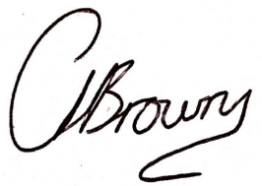
Chair of Governors | Mr L Geary | 

Review
Dated | September 2024
Next review | September 2025

This policy should be read in conjunction with the school’s ‘Managing Medicines – supporting pupils with medical needs’ Policy
Rationale and Aims

Rationale
• To ensure an effective response to injuries and sudden illness in pupils and staff.
• A separate policy is in place for the administration of medication- ‘Managing medicines – supporting pupils with medical needs’
• To provide excellent first aid provision and medical care for pupils and school personnel

Aims and Objectives
• To have in place qualified first aid personnel who are aware of hygiene and infection control procedures
• To have in place essential first aid equipment.
• To have in line excellent lines of communication with the emergency services and other external agencies.
• To have in place staff qualified as a Paediatric and/or First Aider ‘In The Workplace’ across the school including in the areas of administration, teaching assistants, nursery, sports team and the Arts/Sports Centre
• To provide First Aid equipment and provision in accordance with Health & Safety recommendations
• To ensure that all staff are aware of the appointed First Aiders
• To ensure all staff are aware of correct reporting and recording procedures relating to accidents

Responsibilities

Parents and Carers are responsible for:
• alerting school when a health care plan may be required
• personally handing all medicines to the office and collecting at the end of the day.
• completing medication forms (one for each type of medicine)
• ensuring that medicine is correctly labelled with the child’s name, medicine name, dosage required and frequency of administration, cautionary advice, expiry date, storage information and written instructions
• supplying medicine in the original container and disposing of out of date medication
• informing the school whether any adverse effect may result from failure to receive the medicine or possible side effects of its administration

The governing body:
• has nominated a member of staff to take charge of first aid arrangements: this is Sarah Palmer
• delegated powers and responsibilities to the Head Teacher to ensure the school complies with The Health and Safety (First Aid) Regulations 1981 and the Reporting of Injuries, Diseases and Dangerous Occurrences Regulations 1995 (RIDDOR),
• nominated a link governor, Lee Costidell, to visit the school regularly, to liaise with the nominated person and to report back to the GB
• has responsibility for the effective implementation, monitoring and evaluation of this policy

The Headteacher/DSL will:
• ensure the school complies with The Health and Safety (First Aid) Regulations 1981 and the Reporting of Injuries, Diseases and Dangerous Occurrences Regulations 1995 (RIDDOR),
• ensure that the nominated person is suitably trained in first aid and administering medicines, has sufficient time to undertake their role and an adequate budget to purchase first aid equipment, ensure all school personnel are aware of first aid arrangements
• ensure the required number of school personnel are trained in first aid arrangements and hold a valid certificate of competence
• conduct with the Health and Safety coordinator annual risk assessments
• monitor and evaluate this policy
• ensure Health Care Plans are completed with parents and all staff are aware

The nominated person will:
• organise and maintain resources in medical room
• ensure that there are adequate stocks of first aid equipment
• maintain first aid containers at appropriate locations around the school,
• ensure all accidents and injuries are recorded and reported
• inform parents of serious accidents especially head injuries and of any first aid administered, • keep up to date with new developments and resources
• review and monitor medicines in school and ensure paperwork up to date – asthma lists etc • work with SENDCo to ensure Health Care Plans records posters are up to date

Those staff members either Paediatric and/or First Aid at work trained should:
• ensure first aid provision is available for staff, visitors and children during school opening hours
• be available to attend school trips providing first aid cover
• ensure first aid records are kept and accidents and injuries are reported
• assist in organisation of and maintain the medical room
• undertake training in first aid, administration of medicines and awareness of medical problems in pupils
• correct storage of medicine in a secure location in the medical room (including refrigeration),
• keep a record of medicine administered as appropriate
• ensure that the children take their medicine to any out of school activity (this will usually be held by the teacher in charge)

School Personnel- non first aid trained should:
• be aware of first aid arrangements,
• be aware of pupils with known medical problems
• report any concerns they have on the medical welfare of any pupil
• ensure a qualified first aider is notified of any medical emergencies
• ensure a suitably qualified first aider attends any visits or excursions taking place off sit

Procedures
There is a designated room for First Aid located by the Main Reception. All treatments must be in accordance with medical guidelines recommendations. Names of qualified First Aiders will be displayed in the First Aid Room.

First Aid Boxes are located in:
- Designated First Aid Room

Children requiring First Aid treatment should be dealt with initially by the member of staff involved. Depending on the nature of the concern e.g. where there is doubt or in more serious circumstances:
In class:
- a message should be sent by reliable means to either the school office or direct to a qualified First Aider for them to attend the classroom
Play/Lunchtime:
- the child can be sent to the first aid room and accompanied by either an adult or peer (depending on the severity of the concern)

Accidents/injury requiring first aid to pupils should be recorded on IRIS and if necessary, reported to parents via the first aider. All head bumps/injuries will result in parents/carers being informed either via phone call or text, depending on the severity of the injury.

Accidents to staff must be reported using IRIS and a member of SLT informed.

All serious accidents, resulting in a person being taken to hospital, must be reported to the Headteacher or Deputy Headteacher.
The Headteacher or Deputy Headteacher must be informed if it is felt necessary to send or take a person home due to illness or injury.

First Aid Kit
A typical First Aid Kit should consist of the following items;
• 2 small (eye pad) bandages
• 6 medium bandages
• 2 large bandages
• 2 triangular bandages
• 6 safety pins
• 3 pairs of disposable gloves
• 6 antiseptic wipes
• 1 leaflet containing general First Aid advice
• 20 plasters of assorted sizes
Some of the First Aid Kits are required to contain alternative or additional items. Stock levels should be monitored regularly and re-ordered as required. Any items which have passed their expiry date should be discarded safely. The location of all First Aid Kits should be designated with a green cross.

Dealing with body fluids
In order to maintain protection from disease, all body fluids should be considered infected. To prevent contact with body fluids the following guidelines should be followed:
• When dealing with any body fluids wear disposable gloves.
• Wash hands thoroughly with soap and warm water after the incident.
• Keep any abrasions covered with a plaster.
• Spills of the following body fluids must be cleaned up immediately.

Bodily fluids include: • Blood, Faeces, Nasal and eye discharges, Saliva, Vomit

Disposable towels should be used to soak up the excess, and then the area should be treated with a disinfectant solution. Never use a mop for cleaning up blood and body fluid spillages.

All contaminated material should be disposed of in a yellow clinical waste bag then placed in the waste bin in the first aid room. Avoid getting any body fluids in your eyes, nose, and mouth or on any open sores. If a splash occurs, wash the area well with soap and water or irrigate with copious amounts of saline.

Infectious Diseases

If a child is suspected of having an infectious disease advice should be sought from the parent/carers GP and/or NHS service. Parents/Carers can follow the links below to gain information from government guidelines so to reduce the transmission of infectious diseases to other pupils and staff. www.gov.uk/government/publications/health-protection-in-schools-and-other-childcarefacilities/managing-specific-infectious-diseases-a-to-z www.nhs.uk/live-well/is-my-child-too-ill-for-school/

Arts and Sports Centre
Visitors and Clients to the Arts and Sports Centre
Accident reporting and procedures are in place for all visitors/clients of the school.
There are first aid facilities at both the Arts Centre reception and Sports Centre reception. These facilities include AED Defibrillators at both receptions.
All incidents requiring first aid should be reported to the nearest reception area immediately. Visitors/Clients requiring first aid treatment should be dealt with initially by a first aid qualified member of staff. If the injury is of serious concern the person involved will be advised to seek further medical assistance. If necessary, an ambulance will be called at the earliest possible stage.
An ‘Incident, Accident or Dangerous & Occurrence & Initial Management Investigation Report’ should be completed for all accidents/injuries to clients/visitors of the Arts & Sports Centre. These will be stored in lockable units at both the Arts & Sports Centre reception and retained for 10 years
Self Harm
WHAT IS SELF-HARM?
Self-harm is an umbrella term to describe a wide range of behaviours. These are split into 2 sub-categories:
Self-injury: Harming or injuring oneself e.g. cutting, burning, burning the skin, drinking or eating poisons and other acts of self-mutilation.
Harmful Behaviours: Behaviours which could result in long-term harm e.g. over/ under eating, drug misuse, binge drinking, and smoking.
Decision making around self-injurious behaviours

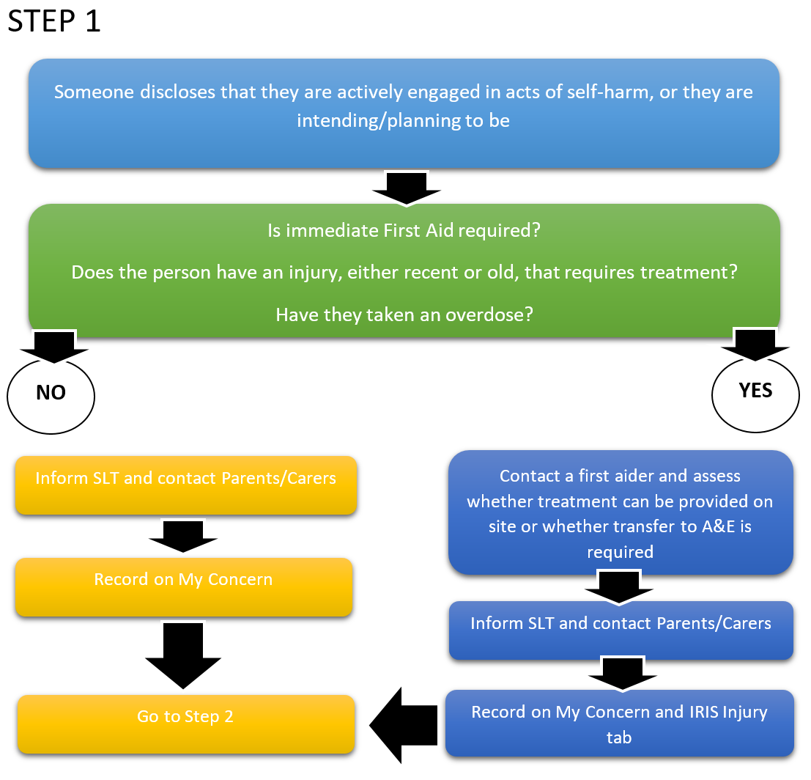

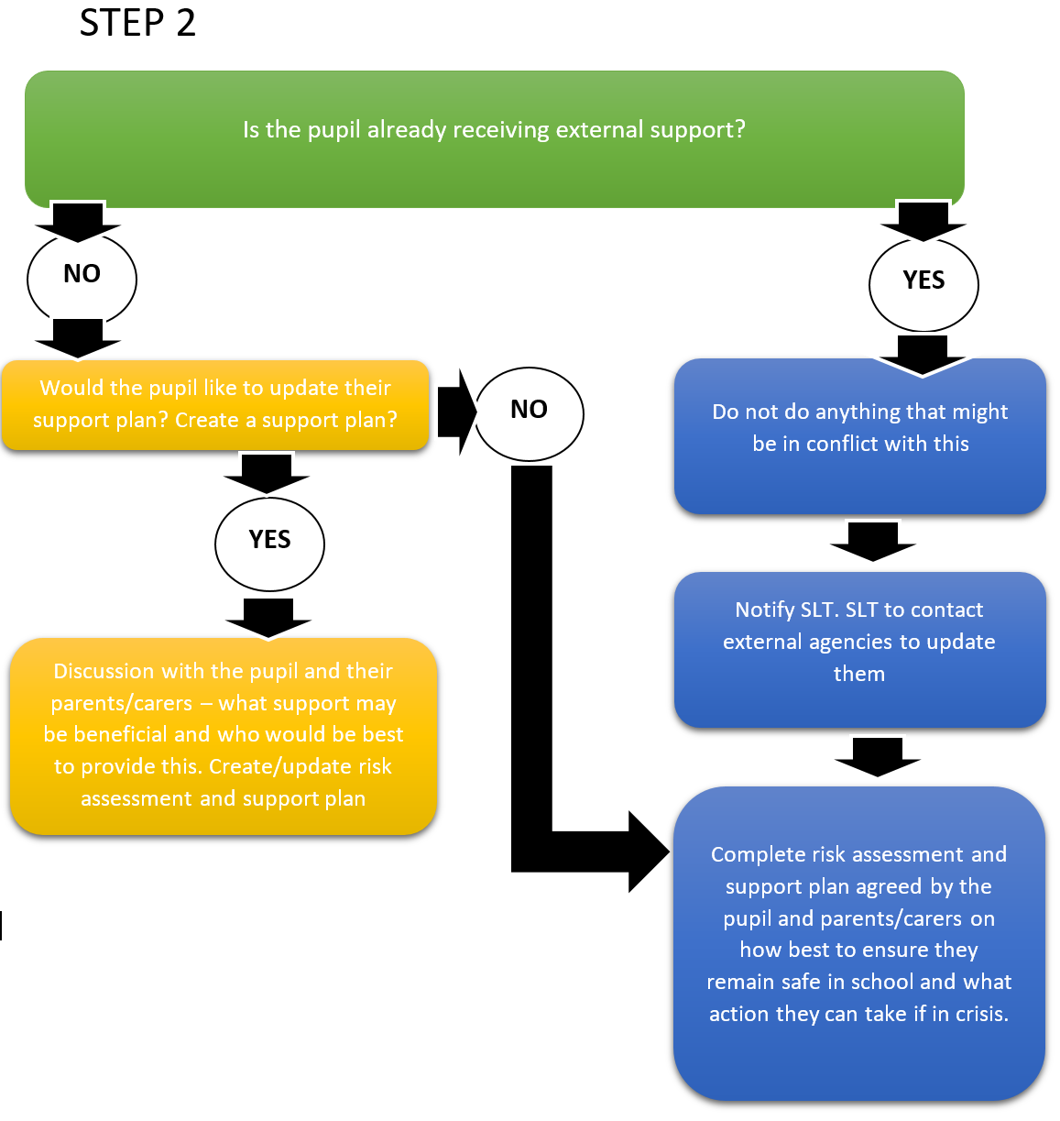

Who informs parents/ carers and when will this happen?
SLT should be notified after following procedure (shown in the flowcharts). It will be SLT’s decision as to when and how parents/carers are informed. This will be done with sensitivity and the meeting will be used to inform Support Plans and Risk Assessments used in school.

Preventative Strategies
Pupils who present with self-harming behaviours and who are at risk of self-harm will have an individual risk assessment which will contribute to the information within a written support plan. The support plan is individualised to the pupil and includes personalised preventative measures specific to the presenting behaviour. This support plan will be reviewed as appropriate if behaviours change.
A trauma informed approach will be utilised by staff to offer alternative strategies to lessen pupils’ social defence systems. At times, staff will make use of dynamic risk assessments in emergency situation
Self Harm
Recording of self-harm incidents/injury
Staff are to record all incidents of self-harm on MyConcern and the actual injury on IRIS under the accident/injury tab. These forms can then be printed for parents’ reference if required.

