Communication and language  Daily talks about their learning during learning and exploring time  Role-play opportunities  Retelling stories through their play  Listening to stories  Answering the register  Follow instructions | Personal, Social, Emotional Development  Transitioning into school  Making friends and building positive relationships  Understanding likes and dislikes | Physical Development  Gross motor – using the climbing frame and large construction  Fine motor – threading, holding small tools, practising with a pencil and paintbrushes  Spatial awareness | Literacy  Phonics – RWI every day 5-10 minutes input  Practising name writing  Forming lower-case letters  Initial sounds
Term 1 – Super Duper Me!
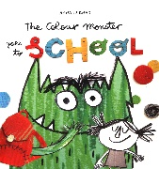
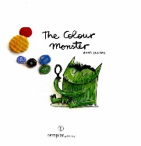
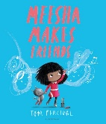
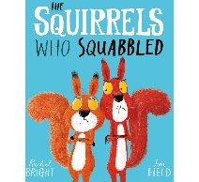
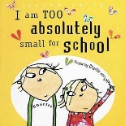
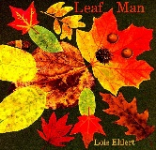
About me and my family, how we are all unique

Maths  Mastering number scheme  Matching and sorting  Comparing amounts  Numbers to 5 – counting, comparing, composing  Patterns  2D shapes  Water – empty/full |  |  | Books we will study:  Focus Fiction books: The Colour Monster Goes to School, The Colour Monster, Meesha Makes Friends, The Squirrels Who Squabbled, I am too absolutely small for school, Leaf man  Non-fiction books: Harvest, people who help us, emergency services, autumn
 | Understanding the world  people who help us (emergency services)  our families and who we live with  our local area  our home  autumn season and seasonal changes  harvest | Expressive Arts and Design  Colour mixing  Primary colours  Self-portraits  Charanga – online songs in the classroom

